3rd revision
Summary Report for SMILE Professional Development Certificate

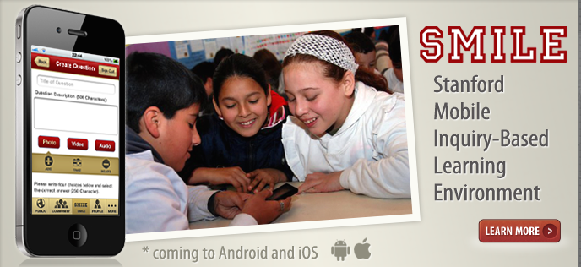

Mira Gillet
account name in SMILE – http://smile.stanford.edu (mgillet)
5 critical thinking questions I created in

- What is the best way to create a SMILE question?
A. Put fact-based questions in, such as 15+15=30.
B. Mark all answers as correct and see everyone's opinion.
C. Put in questions based on world problems that need to be solved.
D. Create this question ;P
- How much Ultraviolet Light passes through car windows? A. 0% B. 50% C. 60% D. 100%
- Why do Transition Lenses become dark when exposed to sunlight?
A. The sun's radiation wears away the lenses.
B. The sun's radiation reflects from the lenses.
C. The glare from the sun.
D. The lenses contain a special type of dye that activates from Ultraviolet light.
- How can we prevent people with mental illness and autism from getting guns? (Select all answers, all are correct.)
A. Putting a gun detector in autistic or mental people that alarms if they are holding a gun.
B. Asking to see buyer's personal information to make sure that they are not autistic or mental.
C. Stopping all gun sales in general.
D. Creating lists of autistic or mental people and giving them to gun store employees and owners.
- What is the most efficient way to get rid of fleas? (Select all answers, all are correct.)
A. Wash your bed sheets commonly.
B. Keep pets away from your bedroom.
C. Put medicine for fleas on your pets.
D. Have no pets.

Evaluation comments on 5 questions created by others in:
(Critical evaluation of questions created by others)

- In 2011, there was a tsunami in Japan that created a meltdown of the Fukushima Daiichi nuclear plant. As a result, all 48 nuclear reactors were taken offline. In February 2015, there was a 6.9 magnitude earthquake off Northeastern Japan. Subsequently, a tsunami warning was issued. What is the most significant risk to the local population?
A. Flooding causing death, displacement, and chaos for residents.
B. Nuclear disaster affecting the island and extending beyond Japan’s borders.
C. Disruption to the local economy and export business.
D. Significant environmental that could take years to restore, revive, or repair.
E. Increased international dependence due to need for emergency assistance.
(This is a 5-star question because it involves high-quality learning and critical thinking. It is based on deep analysis because the answerer must think about the options thoroughly.)
- What color is made by mixing white and red?
  - Gray, B. Red, C. Pink, D. Purple
(This is a 1-star question because is does not involve any critical thinking. It is a simple recall question.)
- What is the state of water at 273.01 K? A. Liquid & gas, B. Liquid only, C. Liquid & solid, D. All the three (gas, liquid & solid)
- (This is a 3-star question because it does not involve lots of critical thinking but it is high-quality. It is a scientific recall question.)
- Currently in the year of 2015, oil prices in the U.S. are low and prices are falling. How would this affect the U.S. in any way?
A. Oil prices will boost economic activity in the U.S.
B. Consumers will be more conservative when spending money.
C. Give more money to consumers to spend on other things. D. A and B
(This is a 4-star question because it requires critical thinking. It is based on deep analysis because the answerer must think about the options thoroughly.)
- As noted in “Korea: Echoes of a War,” U.S. president Harry Truman and his advisers interpreted the North Korean invasion on June 25, 1950, as a direct challenge to the United States by:
A. Japanese emperor Hirohito.
B. North Korean president Kim II Sung.
C. United Nations forces.
D. Soviet dictator Joseph Stalin.
(This is a 3-star question because it does not involve lots of critical thinking but it is high-quality. It is a complex recall question because you need to know background information from a complex source.)

Lesson 1 using
SMILE Workshop at North Star Academy After School Program
Redwood City, CA

School year 2014 to 2015, every Thursday half hour
15 students ages 3rd grade to 8th grade on 6 computers

video of a SMILE workshop delivered
https://www.youtube.com/watch?v=_Yqcdz9clVQ

Roz - google hangout with my class
https://www.youtube.com/watch?v=u6tLJ5pc9zM

How to make a SMILE question
https://www.educreations.com/lesson/view/4-stars/12746664/?s=WhCGXl&ref=appemail

5 Best critical thinking question samples created by participants and comments

1. How can we help Africans so they have easy access to clean water nearby?
A. Build many wells so water is always nearby.
B. Write a newspaper article about the problem.
C. Give each family a replaceable filter.
D. Build fewer wells that have higher quality water.
(This is a 5-star question because it involves critical thinking and is important for the world. This is based on deep analysis and logical reasoning.)
2. Why is carbon dioxide cold?
A. When gas is expanded.
B. Because it comes from trees which are cold from the rain.
C. Because of the gas exchange that occurs with your lungs.
D. Because of the cold air that seeps into your mouth while you sleep.
(This is a 4-star question because it involves critical thinking and important learning. It is based on logical reasoning.)
3. What would happen if an astronaut tried to get to Venus and succeeded?
A. They would die from the heavy amounts of sulfur and methane gas.
B. They would turn into dust.
C. They would die from sulferic acid.
D. They would be safe and they could explore.
(This is a 4-star question because it involves critical thinking and important learning. It is based on logical reasoning.)
4. Why are deaf people unable to hear?
A. They have too much water in their ears.
B. Their nerves are damaged.
C. Their eardrums exploded.
D. They hurt themselves too badly.
(This is a 3-star question because it involves important learning but not much critical thinking. This is a recall question.)
5. When ice cream melts and you refreeze it, why is there more ice then usual?
A. Different temperature at the store.
B. There is a chemical change.
C. Because the ice cream man says so.
D. Because it says so in the ice cream laws.
(This is a 3-star question because it involves critical thinking but not much important learning. This is a question based on logical reasoning.)

Rubric to identify types of questions
- Simple recall
- Deep analysis
- Order identification
- Logical reasoning
- Syntax analysis
- Simple arithmetic
- Grammar analysis
- Identifying relevancy-You need to be able to distinguish relevant information from irrelevant information
- Pattern recognition
10. Algebraic word problem
11.Multiple concept problem

Lesson plan using

Facilitator’s guide revised 1
Step 1: Warm up 5 min box game
Breaking the ice with the audience by
understanding their context.
Put something in a shoe box- kids have to guess what is in the box
by asking the right question.
Instructor to kids :
Ask one question that leads you to the answer of what is in the box.
example: scissors in box.
Kids: Is it fuzzy? no (low level question)
Is it purple? no
What is it used for? (high level question)
Answer: cutting
Scissors are in the box.
Step 2 handout
Sample 5 star question
Estimated time: 10 min Introduce handout
discuss 5 star questions are questions that you learn something by
just reading the question. 5 characteristics of a 5 star question.
Step 3: Activity to inspire questions. (build Prototypes)
Step 4: Try to put questions on paper first
Estimated time: 20 min
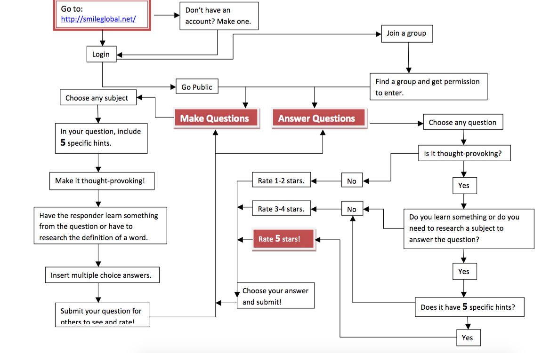
Step 5: Input into SMILE website
Talal’s screen shots that show the path
NOTE to teacher:
It is easiest to make profiles for the younger kids to register them
before hand so they can input questions.
Tips:
input as pairs so the kids can help each other
to make it fun, make one multiple choice answer funny
Step 6 Kids answer and rate each other’s questions- discuss
Tip
try to each all the badges for a prize
discuss comment section
what is considered bullying
Step 7 interview kids on their learning with a video

Lesson plans
design thinking with SMILE
add video
empathy
define, ideate, prototype, TEST by designing questions, surveys in
tip:when you are away from the computer,
you can do questions on paper and save them
to input later.

Reflection note summarizing the facilitator’s and participants’ SMILE experiences (less than 1000 words)
4 photos from the workshop – showing the room with participants, facilitator in front of the participants, etc. (Proper consent forms must be obtained)

Students while they tinker through this hands-on design thinking workshop series.
beginning of article
Teachers Promote Risky Behavior to Develop Creative Mindsets
A small after school program in the Bay Area, Workshop Education, is burgeoning into a design group with guests from around the world coming to see this group in action.
Rebecca Crook visited from South Africa, where she is Academic Dean at SPARK schools, a new network of low-fee private schools in Johannesburg. “When we asked her how long it took to get here, she said it took 31 hours,” one of the Workshop students said.
The Workshop students in grades 3-8 at Northstar Academy, a charter school in Redwood City, wanted to design something for Ms. Crook. She said she needed a way to help her students celebrate the life of Nelson Mandela when she returned to school. After learning more about her problem and brainstorming, the students came up with a prototype. They would record their thoughts about Mandela in a booklet for her to share with her students so they would know how much Mandela meant to people all around the world.
“Thank you so much for meeting with me to speak about Workshop and Design Thinking. I appreciated and thoroughly enjoyed seeing your program in action! I was especially impressed by the fact that your students are able to fluidly move through and lead others in the design process. I kept the Nelson Mandela booklet and cell phone finder prototypes as inspiration as I further develop a child-centered curriculum. Thank you again for letting me experience Workshop!” said Rebecca Crook.
Rebecca is back in South Africa now, but since Workshop showed her how to use SMILE, the Workshop students can still learn from her and she can still learn from the students in California.
SMILE, the Stanford Mobile Inquiry Learning Environment, is a learning management system that allows students to create, share, answer, and evaluate higher order thinking questions in a collaborative manner through the use of mobile technology.
Mira Gillet is the Director of Design Thinking for Workshop Education and Lead Field officer of the SMILE pilot through Workshop. “The students wanted to interact, show their inventions, share their inquiry learning, compare their analytical thinking, and have fun with video recording and hands-on making,” said Ms. Gillet.

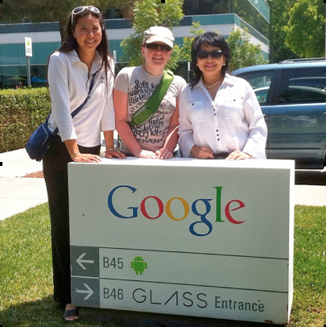
SMILE research team: Mira Gillet, Alison Burek, Roz Hussin, Ms. Gillet’s other projects are PEACE GAME online, top voted learning game through Designing a New Learning Environment and Design Out of the Box to spread design thinking to all.

Through hands-on tinkering and experimenting, students explore design thinking by repurposing recycled electronic devices to create prototypes of their design ideas. They also practice their research and inquiry learning skills through the SMILE platform.
Working on iPads and other mobile devices, they learn to inspect, inquire, seek, analyze, formulate and answer questions that they are curious about during the design process. Each student, working in pairs, teams or independently, generates his/her own questions and competes to see who can create the highest-rated question and who can answer the most questions correctly.
This inquiry based creativity experience empowers every student to engage at their own pace, gain proficiency in mobile technology, exercise their imagination, and realize their skills.

Because Workshop takes risks and advantage of free learning applications, they also experienced 21st century learning using the Google Hangout with Roz Hussin, a Stanford Research Associate and Instructional Design Technology Specialist working on SMILE with Ms. Gillet. Originally from Malaysia, Roz taught Workshop students remotely from Nebraska using Google Hangout that incorporates photos and slides into a video call.

As research colleagues, the two are collecting material that may be used for a future online SMILE certification course for teachers.

Ms. Hussin walked Workshop through slides showing the overview of the week’s theme – how to solve the water crisis in developing countries. After that, the kids designed water filters. Before Ms. Hussin’s presentation, the kids didn’t know there was a water problem in Africa. After taking risks and designing water filters of their own, kids researched and created their own questions for SMILE, such as “How do sand filters work?” and “How can I get my water filter prototype to work?

These Amazing Kids
The diversity of this Workshop Education group reflects the diversity of Silicon Valley. Students come from Latino, Iranian, Filipino backgrounds and a wide range of economic circumstances. Most importantly, these kids are not afraid to take appropriate risks to experiment in order to design products and processes to change the world. They gain creative confident by practicing Stanford Design School’s Methodology.

This combination of design thinking and inquiry learning is “hands on” which turns minds on.

“Jacob Guernsey is working on his MBA in Design Strategy at San Francisco’s California College of Arts (CCA) which BusinessWeek magazine rates as one of the world’s best design schools. He visited Workshop and said, “I was amazed that the kids are learning the same thing I am in my Masters Program.”
The pedagogical model that has been developed involves four-parts:

(1) Design Thinking – Kids are given a problem to solve (or a theme around which they define a problem); They then embark in creative hands-on “making” or “tinkering” (or taking apart an existing designed object). The end product is a prototype of their design solution.

(2) Inquiry Learning – Kids create questions based on what they have discovered/created in the design thinking phase. They can write the questions on paper first, or directly input into the SMILE platform, depending on availability of devices.

(3) Analytical Thinking – Kids answer questions created by peers and evaluate those questions based on a given rubrics (scale of 1-5 stars: a “good” question is one that provokes you to think further and ask more questions). This part is carried out on the SMILE platform.

(4) Reflection + Metacognition – Kids interview each other and document their thoughts in all three processes. This is documented through video recording, drawing diagrams, and sharing with others. The teacher’s role is to facilitate the recollection and acknowledge key points presented by the kids.

Ms. Gillet has observed a variety of outcomes from this strategic approach — some positive (which SMILE will want to replicate and scale), plus a few challenges (which are suggestions for SMILE platform design improvements). Since this combination of design thinking with inquiry learning is dynamic, there are some of the on-the-ground challenges. The team is extremely flexible and changes to the needs of the students.

Workshop Education
Workshop Education is unique because it combines constructivism and connectivism theories together. Students design products, processes, and questions that lead to innovation to strengthen their 21st century skills.

Workshop Education, a unique model for after school enrichment, was created by Alexa Frisbie in 2009. Ms. Frisbie, an educator and a parent, created Workshop when she couldn’t find a program that combined innovative enrichment with scheduling flexibility. “We are so close to such amazing learning opportunities, the d.School at Stanford, Bay Area Writing Project in Berkeley, innovation in Silicon Valley, artists in San Francisco, and I wanted to connect students to these vibrant real life learning experiences. The program has expanded to five schools in Hillsborough, Redwood City, and Montara, CA. Workshops are offered daily from school dismissal until 5:30, and parents choose enrichment Workshops that work for their schedule.

During Design Thinking Workshops, students design solutions for their classmates, families, or the world. One boy created this solution to making mornings better with him mom.

Come to workshop and we will design something important to you. It will make you SMILE.

Another group took on a project of designing a product to help the blind.

“Empathy is a huge piece of learning design thinking. You have to deeply understand a situation before you can create a product or process to improve it. Children are often in a position where they are mainly consuming other people’s creations via iPad, iPhone, video games, and television. Workshop is a little oasis where we expect children to be a part of the learning and growing process,” said Ms. Frisbie.

Or as one student at Workshop said, “I have never had the chance to build my ideas before.

Connecting with fellow innovators, Workshop and SMILE are making sure that more children get that opportunity.
